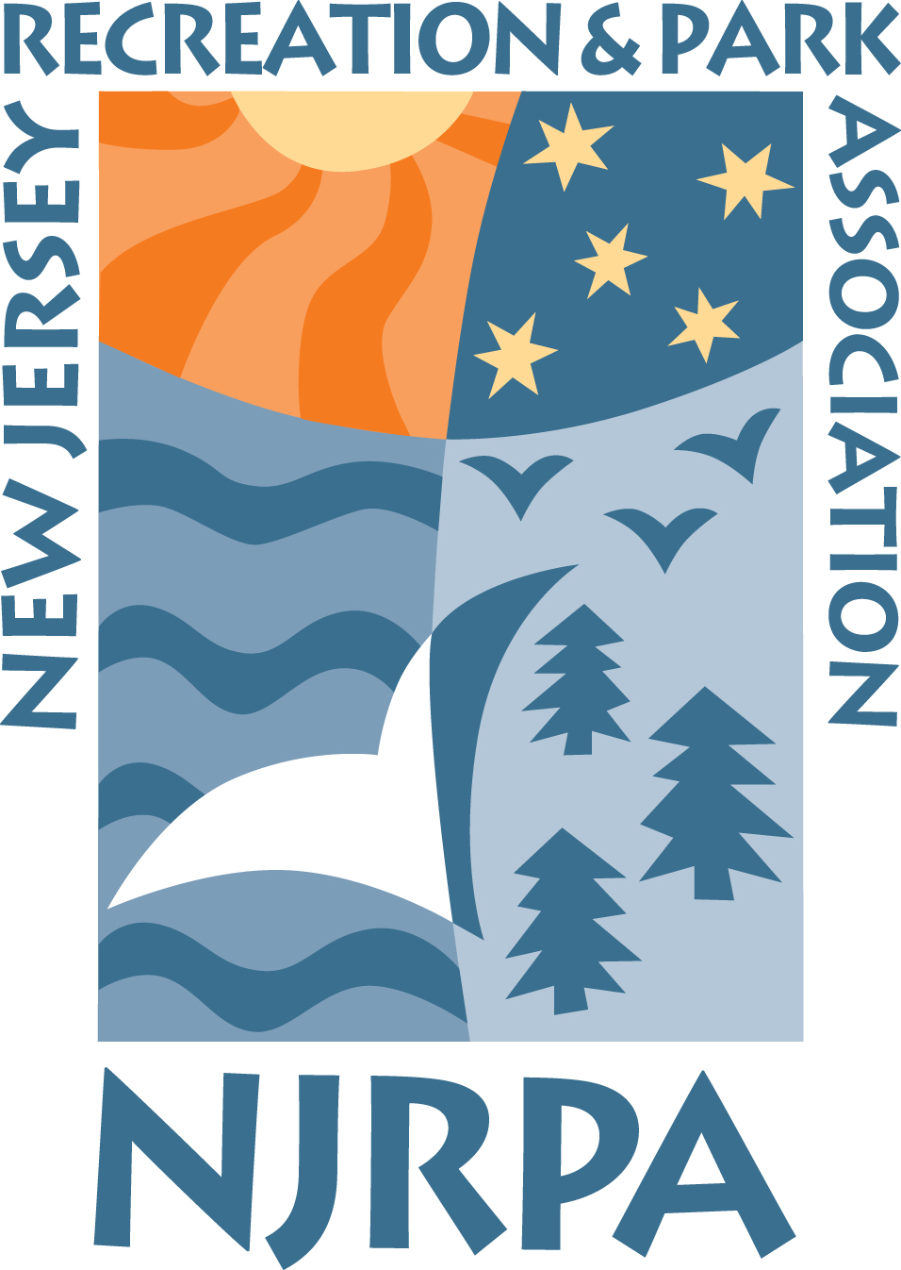

2019-2020
Winter Consignment Program

GATE NJRPA # ORDERED
PRICE PRICE

BLUE MOUNTAIN, Palmerton, PA

Weekend/Holiday (8 hour ticket) $70.00 $62.00 ______________
Midweek (non-holiday/8 hour ticket) $60.00 $52.00 ______________
Night (anytime, 4pm – 10pm) $45.00 $32.00 ______________

Tickets start at the time of the guests first lift ride and expires after eight hours of skiing or riding.
Holidays include: Christmas Eve Through New Year’s Day
Martin Luther King Day
President’s Day

JACK FROST/BIG BOULDER, Blakeslee, PA

Weekend/Holiday Adult (Open to Close, age 18 & older) $68.00 $54.00 ______________
Midweek Adult (JFM Only) $55.00 $42.00 ______________
Weekend/Holiday Youth (Open to Close, age 7 to 17) $52.00 $43.00 ______________
Midweek Youth (JFM Only) $40.00 $31.00 ______________

Big Boulder is closed Christmas Eve; Big Boulder is open from 12pm to 6pm Christmas Day;
Jack Frost is open 9 to 4 pm Christmas Eve; Jack Frost is closed Christmas Day:
Holiday Schedule: December 26, 2019 thru January 1, 2020, January 18-20, 2020, February 15-21, 2020

SHAWNEE MOUNTAIN, Shawnee on Delaware, PA
Shawnee Mountain will provide an online discount program for 2019-2020. Shawnee Mountain eTickets. Agencies can
provide residents with a username and password provided by NJRPA. Resident can then go to shawneemt.com, enter
the username and password provided by NJRPA, choose product desired, purchase with a credit card or debit card, and
receive an email confirmation with link to printable eTickets. Residents bring their eTickets to the mountain and
redeem at the lift ticket windows.

www.Shawneemt.com then go to “Tickets & Rentals” tab and then “eTicket on drop down screen”
Club Name (Username) - NJRPASSOC & Password - njrpassoc1
See attached Shawnee Mountain info sheet for prices and hours

2019-2020

Winter Consignment Program

Gate NJRPA # Ordered
Price Price
ADVENTURE AQUARIUM, Camden, NJ

Adult (13 yrs and up) $31.99 $23.50 ______________
Child (ages 2-12 yrs) $23.99 $19.50 ______________
3D Theatre is now included in your ticket price (Previously a $3.00 add on)

MEDIEVAL TIMES, Lyndhurst, NJ

General Admission $62.99 $37.00 ______________
Two-Hour Live Show *Four-Course Medieval Feast*Magnificent Pure Spanish Horses*Majestic Castle with Indoor Arena*
Authentic Jousting Tournament and Sword-to-Sword Combat

iPlay America, Freehold, NJ

iPlay America will provide an online discount program for 2019-2020 iPlay America’s NJRPA Discount Program offers 3 great options. To purchase discount tickets visit us at Tickets.iPlayamerica.com and enter the code NJRPA. Residents can choose the product desired, purchase with a credit card or debit card, and print their eTicket to iPlay America.

CRAYOLA EXPERIENCE, Easton, PA

Crayola Experience will provide an online discount program for 2019-2020. Visit us at tickets.crayolaexperience.com and enter the code NJRPA. Residents can purchase with a credit card or debit card and print their eTicket to Crayola Experience.

2019-2020 Community Service Winter Ticket Program Order Form

Name____________________________________________Phone__________________Fax_________________

Agency______________________________________________________________________________________

Address_____________________________________________________________________________________

Email_______________________________________________________________________________________

Fax to Ruth-Ann Bellon at (609-356-0475) OR mail to NJRPA, 1 Wheeler Way,
Princeton, N.J 08540 or email to rbellon@njrpa.org Questions ? Call Ruth-Ann at 609-356-0480 ext. 15

