Leonia Recreation Commission

370 Broad Ave., Leonia, NJ 07605
Tel. (201) 592-5783 Fax (201) 592-8654
www.leonianj.gov
JON ABOUAF
COMMISSION CHAIRPERSON

SEAN KRAKOWER
RECREATION SUPERINTENDENT

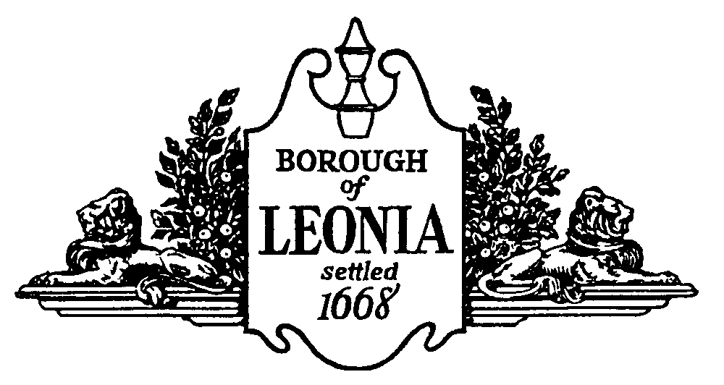

RECREATION OFFICE MANAGER
The Borough of Leonia has an immediate full-time position vacancy in the Recreation Department for an Office Manager. Candidates must have previous office experience including a strong background in bookkeeping to assist with purchasing and payroll. Excellent communication skills are required. In addition, a strong proficiency in Microsoft Excel and Word, as well as Community Pass or experience with similar recreation software is necessary. A flexible schedule is required to accommodate weekend and evening hours. Salary is dependent upon experience and other qualifications. Proficiency in the Korean language is a plus. High School Diploma or equivalent required; college coursework and/or degree preferred.
Please send resume, cover letter and salary history to: Andrea Wardrop, Borough Administrator, by close of business March 11, 2022 via email: awardrop@leonianj.gov. The Borough of Leonia Vaccination Policy requires that any individual seeking employment within the Borough of Leonia must show proof of full vaccination.
The Borough of Leonia is an equal opportunity employer.

