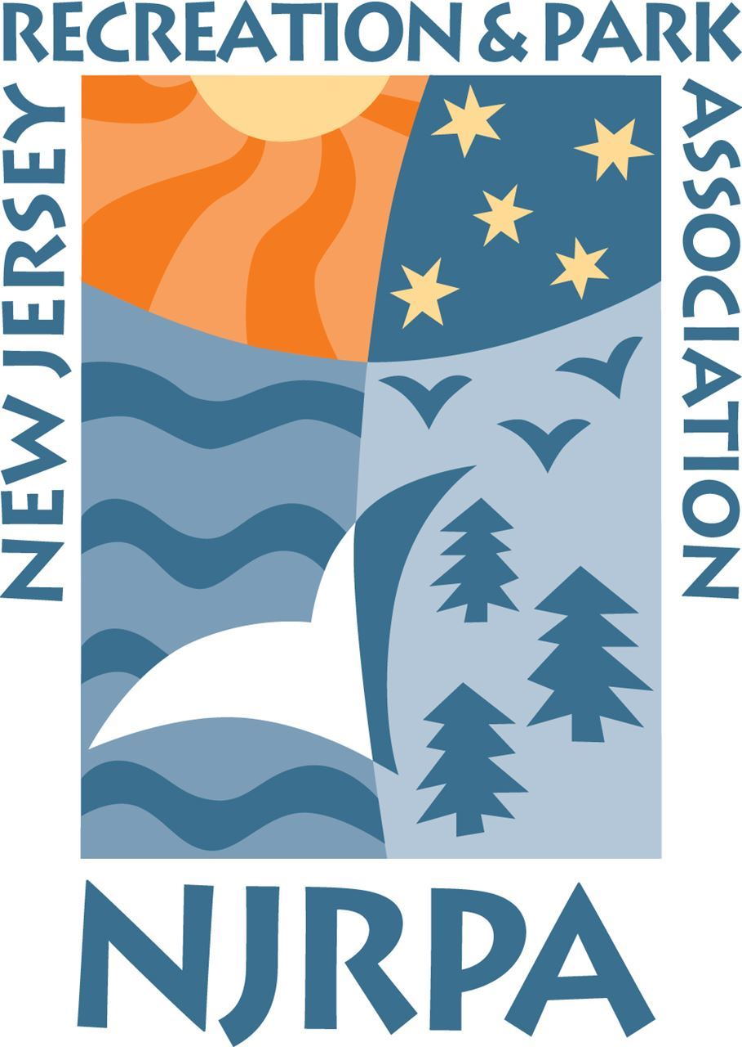
2021 Season
Aquatics Section Survey
Contents
Facilities and Staffing 3
Season and Daily Passes 5
COVID-19 10
Programming 13
Salaries 14
Concessions 15
Swim team 17
Swim Lessons 19
Rentals 21

Facilities and Staffing

Facilities Types - What types of facilities does your agency operate?

Indoor Pool Outdoor Pool
Splash pad/spray park Waterfront (e.g. lake, beach, etc)
Spa Playground-based pool
Lazy River Other

27

0 5 10 15 20 25
2
12
6
0
1
1
4

Facilities Numbers - Does your agency operate more than one aquatic center (i.e. facilities at different locations/properties)
13

Yes

No 20
0 5 10 15 20

How many seasonal staff directly tied to your aquatics facility/facilities do you have during the summer? Do not include year-round staff or maintenance staff hired for multiple spaces/facilities.

Less than 15
15 - 25
26 to 40
41 to 60
61 to 80
80+

7
7
5
4
4
6

0 1 2 3 4 5 6 7

Green Acres - Is your aquatics facility subject to NJ Green Acres participation?

Yes
7

No 18
0 5 10 15

Outsourcing - Do you outsource any aspect of your aquatics facility operations, such as lifeguards, maintenance, CPO, etc. (not including food concession). Please explain and also list the name of the company that provides the outsourced service.

What company do you use to train your lifeguard staff?

American Red Cross Ellis & Associates Starfish Aquatics
National Aquatics Safety Company
YMCA BSA
Other
24

0 5 10 15 20
1
1
0
1
0
5

Season and Daily Passes

Do you charge a seasonal membership fee for residents?

Yes 29
3
No
0 10 20

Discounts - Do you offer discounted memberships for special categories? For example, senior citizen, military/first responder, college students, youth, etc?

Yes 23
6
No
0 5 10 15 20

Season Pass - Do you charge a seasonal membership fee for non- residents?

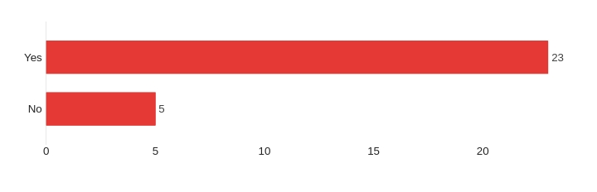

Do you offer discounted memberships for Non-residents in special categories? For example, senior citizen, military/first responder, college students, youth, etc?

Yes 14
9
No
0 5 10

Do you charge a daily fee for use of your facility to residents?

Yes 17
14

No

0 5 10 15

Would daily passes be available normally, but were not available because of the COVID-19 pandemic and associated restrictions?

Yes
2

No 13
0 5 10

Do you offer discounted day pass for special categories of patrons?

Yes
1

No 18
0 5 10 15

Do you charge a daily fee for use of your facility to Non- residents?

Yes 9
7
No
0 2 4 6 8

Seasonal Fees - Residents

RES | Seasonal fee for individual | Seasonal fee for joint/ married | Seasonal fee for families | Seasonal fee for senior citizens (single) | Seasonal fee senior citizens (joint/married) | Seasonal fee for house guest/ caretaker
Min: | $80 | $130 | $150 | $0 | $0 | $5
Max: | $375 | $495 | $695 | $225 | $390 | $450
Average: | $216 | $328 | $422 | $98 | $174 | $142
Count | 26 | 23 | 26 | 26 | 11 | 19
Seasonal fee for youth (indicate age cut-off) | 164 10 or older
 | Free ages 4 and under
 | $106 (17)
 | Under 5 free 5-25 Student $210
 | $5.00- Under Age 5 are Free
 | $140 10yrs-17 yrs old
 | 120 (ages 2-15)
 | $85 (23)

Seasonal Fees – Non-Residents
NON RES | Seasonal fee for individual | Seasonal fee for joint/ married | Seasonal fee for families | Seasonal fee for senior citizens (single) | Seasonal fee senior citizens (joint/married)
Min: | $100 | $175 | $230 | $105 | $0
Max: | $480 | $1,200 | $1,060 | $410 | $500
Average: | $322 | $541 | $614 | $217 | $271
Count | 21 | 16 | 20 | 15 | 12

Daily Fees – Residents

RES | Day pass for individual | Day Pass for joint/ married | Day pass for families | Day pass for twilight/evening Hours | Weekend | Senior/Youth
Min: | $5 | $5 | $5 | $5 | $10 | $5
Max: | $40 | $25 | $12 | $12 | $19 | $11
Average: | $16 | $14 | $10 | $9 | $15 | $9
Count | 19 | 5 | 4 | 5 | 7 | 6

Daily Fees – Non-Residents

NON RES | Day pass for individual | Day Pass for joint/ married | Day pass for families | Day pass for twilight/evening Hours | Weekend
Min: | $10 | $18 | $18 | $5 | $15
Max: | $40 | $18 | $18 | $10 | $30
Average: | $20 | $18 | $18 | $8 | $23
Count | 10 | 3 | 3 | 3 | 3
*only 1 respondent had discounts for youth/senior for non-residential day passes.

COVID-19

Were you notified by your local health officer that contact tracing determined COVID-19 transmission may have occurred at your facility? If yes, where?

Covid-19 Guest Issues - Did you have any guest/patron related issues with COVID-19? Please explain (e.g. had to remove guests/patrons for not following rules, excessive mask enforcement, etc).

Covid-19 Staff Issues - Did you have any staff related issues with COVID- 19? Please explain (e.g. closed due to staff illness, added additional staff to cover for illness, shortened hours, etc).

Did you make any changes to how you sold memberships or daily passes as a result of COVID-19 for the 2021 season?

Did you have a reservation system for admission for last summer, 2020?

Yes
10

No 20
0 5 10 15 20

Did you have a reservation system for admission for this summer, in 2021?

Yes
7

No 24
0 5 10 15 20

Due to COVID-19, did your facility decide to reduce membership or daily pass sales in 2021? If so, by what percentage

Are there any changes due to COVID-19 you plan on carrying forward indefinitely?

Programming

What programming offerings were made in 2021 relative to 2020?

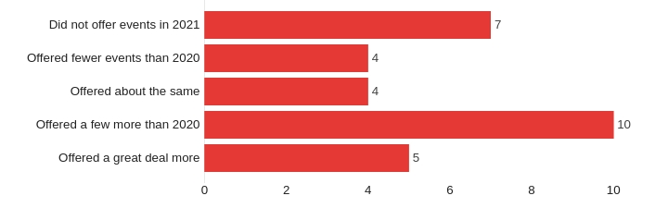

For 2021 - How does your special events/programs compare to pre-COVID levels?
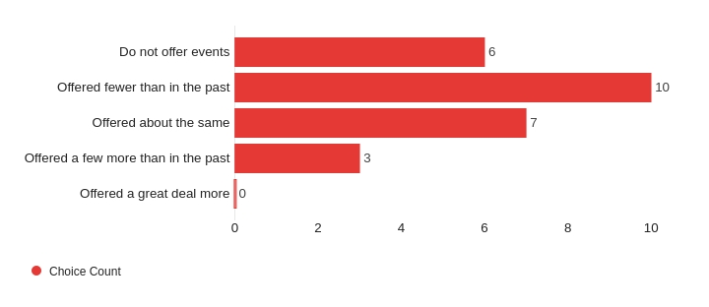
Did you implement any *new* programs for 2021? Please describe.

Do not offer new special events/programs | 14
Outdoor programming | 2
Virtual Programming | 1
Others | 6
 | 0
Total | 23

Salaries

Head Manager Assistant Manager

 | Hourly | Salaried
Min: | $17 | $10,000
Max: | $40 | $20,000
Average: | $25 | $12,933
Count | 9 | 13
 | Hourly | Salaried
Min: | $14 | $5,000
Max: | $21 | $15,000
Average: | $18 | $9,140
Count | 11 | 13

Swim Team Coaching Staff*

 | Head Coach | Assistant Coach
Min: | $1,200 | $800
Max: | $13,491 | $3,120
Range: | $3,649 | $1,531
Count | 14 | 12

* Only one respondent was hourly - $20/hr Head Coach, $13/hr Assistant Coach

Hourly Staff

 | Head Lifeguard | 1st Year Guard | 2nd year | 3rd Year+
Min. | $12.00 | $9.00 | $9.50 | $10.40
Max. | $18.00 | $16.00 | $17.00 | $17.00
Average | $14.33 | $11.99 | $12.40 | $12.65
Count | 18 | 25 | 20 | 23
Special Rates | Hourly Rate + $.50
 | Hourly Rate + $1

 | Maintenance Staff | Front Desk | Group Swim Instructor | Covid Ambassador
Min. | $9.25 | $8.50 | $10.00 | $11.25
Max. | $14.50 | $13.00 | $20.00 | $25.00
Average | $11.64 | $11.35 | $12.97 | $15.48
Count | 14 | 20 | 9 | 10
Special Rates |  |  | Hourly Rate + $1
 |  |  | Hourly Rate + $1
 |  |  | Hourly Rate + $1.50
 |  |  | $300/week
 |  |  | $17/class

Concessions

Do you offer concessions or food on site?

No, not at all Special events/programming
5
2
4
Yes - run in-house

Yes - outsourced 18
0 5 10 15
How were concession sales for 2021 relative to 2020?
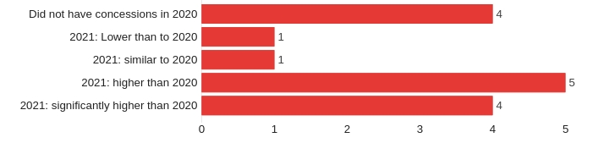

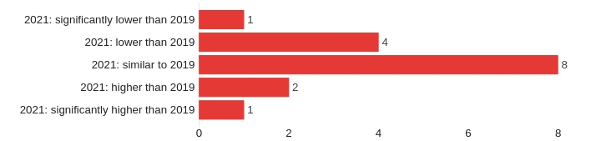
How were concession sales for 2021 relative to 2019?

How were concession sales for 2021 relative to the average sales for 2016 to 2019 (3 year average)?

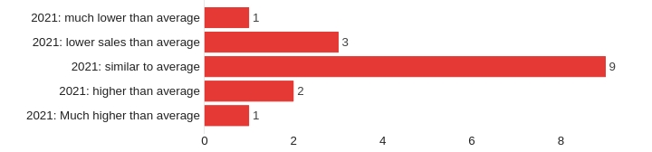

Outsourced Concessions

How were your concessions sales for the following years?

 | 2019 | 2020 | 2021
Min: | $1,500 | $1,500 | $1,500
Max: | $21,000 | $21,000 | $21,000
Average: | $8,318 | $6,125 | $7,658
Count | 15 | 9 | 13

Are you planning on having concessions again in 2022?

Yes 17
0
0
Maybe
No
0 5 10 15

Swim team - Do you have a swim team

Yes 22
6
No
0 5 10 15 20

Swim team - Is your team run:

In-house using our staff 18
4
Run by outside organization
0 5 10 15

What are the costs and structure of your swim team? For example, how much per child, and do you offer multi-child discounts?

What are the costs and structure of your swim team? For example, how much per child, and do you offer multi- child discounts?
$35 per child
$40.00/per child (2nd+ child $25.00)
$40/child$80 family max; $100 non-pool member
$45 per child
$50 per and $20 for 3rd and 4th ect
$55.00 per child
$65/pool member, $110/non pool member
$70 per child
$70/first child; $55/second child. Swim Team only $300 residents/$350 non-residents
$80 per child
$100 per child
105 per season per child
$110 per child, no discounts for pool or lake members. $125 per child for non-members.
$148/child - no multi-child discount but we offer financial aid
$190/child
$200/swimmer

How are payments handled for your outside vendor swim team? For example, do you take registrations and pay the company? Or does the company send you a per-person payment or a flat fee for the summer

We handle payment and registration
Local parent runs organization, they handle all fees etc. We offer space only We take registrations, pay expenses, retain 25% of registration and balance is paid to organization
Swimmers signup as members. they pay the swim team a team fee.

Swim Lessons

Do you offer swim lessons?

Yes 23
5
No
0 5 10 15 20

Are your lessons run:

In-house using our staff 20
3
Run by outside organization
0 5 10 15 20

What program do you use for your swim lesson curriculum? If you use a home-grown curriculum, indicate if it is based off of one of these national programs.

American Red Cross 12
2
0
1
7
Starfish Aquatics Y Programs
Ellis and Associates Other (please specify)
0 2 4 6 8 10 12

Swim Lesson Inside - What are the costs and structure of your swim lesson program? For example, how much per child, do you offer multi- child discounts, how many classes per session?

$35 for 12 classes
Members: $40; $Non Member Residents: $80; Non-Member Non-Residents: $120.00 (8x 30-min lessons)
$76 for 4 weeks (3x per week) per child. No multi-child discount but we offer financial aid
only private in 2021 - 40 per half hr per child
$80/session. Session is 10 days, 45 min per day. No discounts.
$32 per child provides eight 30 minute classes over two weeks. (Member Rate) $64 for non-members.
Four 1/2 hour lessons per week $50, weekly sessions, no multiple child discounts.
Group. Pool Memeber $45/8 sessions, Individual $25/session
45 per week (M-Th 1/2 hour lesson)
$120 for daily week session
$25.00 per 8 day session
Varies from $40 - $100 per set of lessons
$100/child for 9 classes
varies
Class are $75/child for 8 30 minute classes. We net about $350/group lesson
$20/child with pool membership; $100/child non member
$100/child, 8-45 minute classes a session

How are payments handled for your swim lessons? For example, do you take registrations and pay the lesson company? Or does the company send you a per-person payment or a flat fee for the summer (similar to a rental)?

We handle registration and are charged a headcount fee by the vendor.
We took the registrations and then were invoiced and paid the vendor. Payment is made to the company

Rentals

Do you offer your facility to rent to outside groups?

Yes
10

No 18
0 5 10 15

Rentals - What kind of rental opportunities do you offer?

We rent to swim teams 6
0
5
We rent to swim lessons We rent pool space for parties
0 2 4 6

Rental Priority - How do you accept rental requests, review and approve requests?

We have long-standing relationships with a couple local swim teams that get priority. After that we take first come first served if we have available space
The Pool Commission reviews each year and votes. Via registration form - approved by recreation director
Email the Rec Dept. and submit an application. We rent the beach area for camps, parties and have exclusive Wibit Rentals.

We rent out our Wibit for private Summer Camps as well as private parties
Through an application form submitted to the Parks and Recreation Office. By phone, email, or mail. Approval is based on availability thrrough email and contract
Permit forms must be filled out and coordinated with the Aquatics Manager city facility application
Written request and based on space availability and staff availability. Typically early morning.

Rental closing - Do you allow rentals when the facility is open to members/public?

Yes
3
1

No 6
It depends
0 2 4 6

Rental Times - When do you typically offer rental times to outside groups?
Weekday Mornings Weekday Afternoons
4
3
6
Weekend Mornings 7
Weekend Afternoons
0 2 4 6

2021 Aquatics Section Survey Snapshot

Overview: Based on roughly 35 responses:

60% operate 1 facility,
40% have multiple aquatic centers

51% have outdoor pools
22% have splashpads
11% have waterfront facilities

40% smaller than 40 seasonal staff
40% between 40 and 80 staff
20% greater than 80 seasonal workers

50% do not outsource operations or maintenance
20% outsource opening/closing
10% outsource either maintenance, staffing and/or swim lessons

75% use American Red Cross lifeguarding
25% use either Sarfish, Ellis, YMCA or others.

Memberships

90% charge a membership fee
82% allow non-residents to buy a membership

54% sell daily passes for residents
56% sell daily passes for non-residents

COVID-19

82% had no reportable outbreaks with Covid-19

78% had few or no issues with staff issues because of Covid-19
22% had ill or exposed staff
0% reported significant closures as a result of staff illness

40% changes operations procedures for Covid-19, including online only sales

50% reported running fewer programs and special events prior to Covid-19
50% reported running the same number or more than before Covid-19

Hourly Staff

 | Head Lifeguard | 1st Year Guard | 2nd year | 3rd Year+
Min. | $12.00 | $9.00 | $9.50 | $10.40
Max. | $18.00 | $16.00 | $17.00 | $17.00
Average | $14.33 | $11.99 | $12.40 | $12.65
Count | 18 | 25 | 20 | 23
Special Rates | Hourly Rate + $.50
 | Hourly Rate + $1

